**Lab 2 : Web_API_HandsOn**

**Program.cs**

using Microsoft.OpenApi.Models;

var builder = WebApplication.CreateBuilder(args);

// Add services

builder.Services.AddControllers();

builder.Services.AddEndpointsApiExplorer(); // <-- needed for Swagger

builder.Services.AddSwaggerGen(c =>

{

c.SwaggerDoc("v1", new OpenApiInfo

{

Title = "SwaggerApiDemo",

Version = "v1",

Description = "Demo API with Swagger and Postman",

Contact = new OpenApiContact

{

Name = "Shubhang",

Email = "shubhang@example.com"

}

});

});

var app = builder.Build();

// Enable Swagger

app.UseSwagger();

app.UseSwaggerUI(c =>

{

c.SwaggerEndpoint("/swagger/v1/swagger.json", "SwaggerApiDemo v1");

});

app.UseHttpsRedirection();

app.UseAuthorization();

app.MapControllers();

app.Run();

EmployeeController.cs

using Microsoft.AspNetCore.Mvc;

[ApiController]

[Route("api/emp")]

public class EmployeeController : ControllerBase

{

private static List<string> _employees = new List<string>

{"John", "Jane", "Alice"};

[HttpGet]

public IActionResult Get()

{

return Ok(_employees);

}

[HttpPost]

public IActionResult Post([FromBody] string name)

{

_employees.Add(name);

return Ok($"Added: {name}");

}

}

**GET REQUEST:**

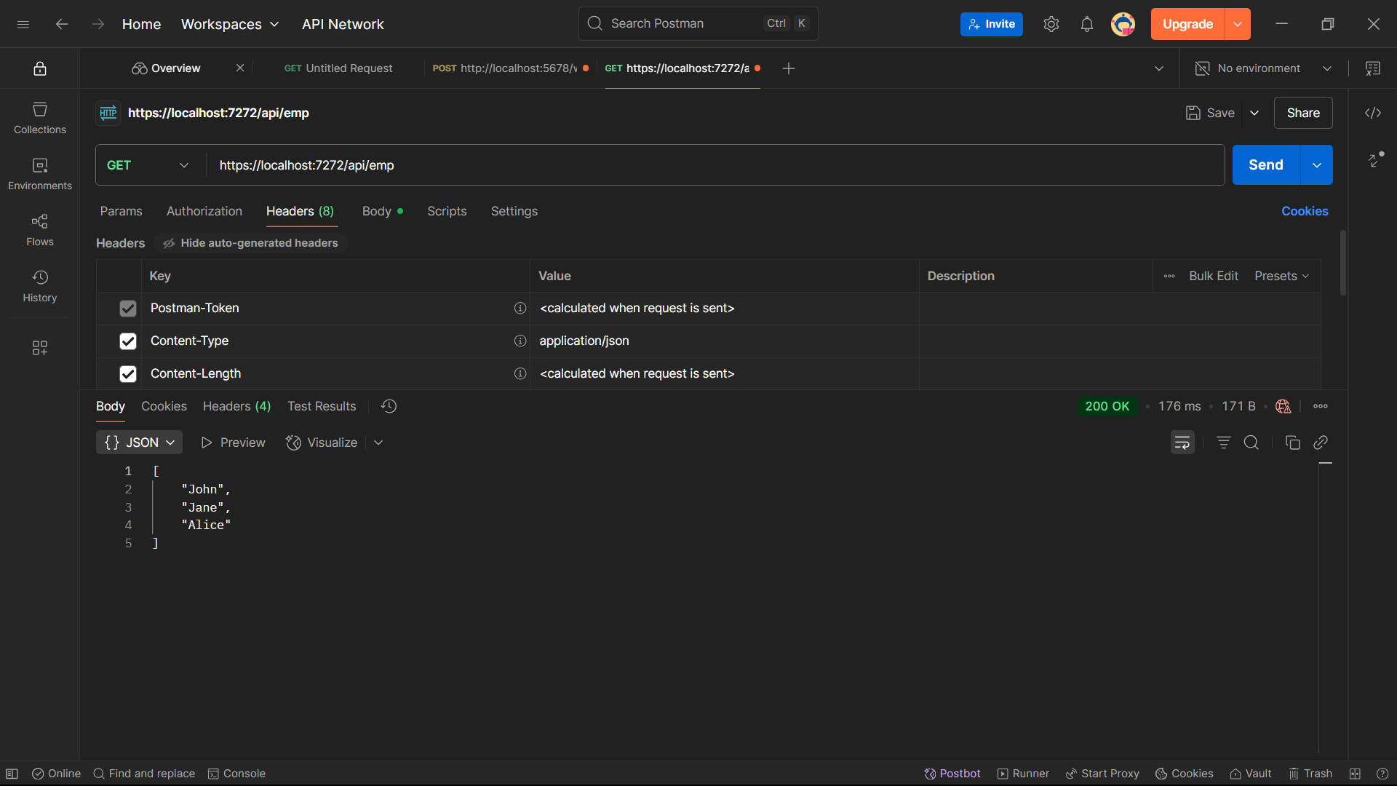

**POST REQUEST:**

